Software Design Specifications

[AppraiseChain]

Version: [01.08]

Project Code
Supervisor | Dr. Shahbaz Siddiqui
Co Supervisor | -
Project Team
Submission Date

[Instructions]
- No section of template should be deleted. You can write ‘Not applicable’ if a section is not applicable to your project. But all sections must exist in the final document.
- All comments/examples mentioned in square brackets ([]) are in the template for explanation purposes and must be replaced / removed in final document.
- This’ Instruction’ section should also be removed in final document.
- MS-Word Reviewing feature must be used to get the document reviewed by PMs or supervisors.

Document History
[Revision history will be maintained to keep a track of changes done by anyone in the document.]
Version | Name of Person | Date | Description of change
1.0 |  | 09/13/24 | Document Created
1.1 |  | 10/19/24 | ERD design
1.2 |  | 10/29/24 | Relations between entities
1.3 |  | 11/012/24 | Data Dictionary for all tables
1.4 |  | 11/22/24 | Sequence Diagram 1
1.5 |  | 11/27/24 | Sequence Diagram 2  Sequence Diagram 3
1.6 |  | 12/06/24 | State Diagram 1,2
1.7 |  | 12/09/24 | State Diagram 3,5
1.8 |  | 12/11/24 | State Diagram 4

Distribution List
[Following table will contain list of people whom the document will be distributed after every sign-off]

Name | Role
Dr.Shahbaz Siddiqui | Supervisor
- | Co Supervisor

Document Sign-Off
[Following table will contain sign-off details of the document. Once the document is prepared and revised, this should be signed-off by the sign-off authority.
Any subsequent changes in the document after the first sign-off should again get a formal sign-off by the authorities.]

Version | Sign-off Authority | Project Role | Signature | Sign-off Date
1.8 | Supervisor | Supervisor | Dr. Shahbaz | 12/10/2024

Document Information

Category | Information
Customer | FAST-NU
Project | AppraiseChain
Document | Software Design Specification
Document Version | 1.8
Status | Draft
Author(s) | Shaikh Azan Asim  Goutam Kumaar  Sooraj Kumar
Approver(s) | Dr. Shahbaz Siddiqui
Issue Date
Document Location
Distribution | Advisor  Project Coordinator’s Office (through Advisor)

Definition of Terms, Acronyms and Abbreviations
[This section should provide the definitions of all terms, acronyms, and abbreviations required to interpret the terms used in the document properly. ]

Term | Description
ASP | Active Server Pages
DD | Design Specification
KPI | Key Performance Indicator
AI | Artificial Intelligence
Tf | Tensor Flow
HOD | Head of Department

Table of Contents
1 Introduction 8
1.1 Purpose of Document 8
1.2 Intended Audience 8
1.3 Document Convention 8
1.4 Project Overview 8
1.5 Scope 8
2 Design Considerations 9
2.1 Assumptions and Dependencies 9
2.2 Risks and Volatile Areas 9
3 System Architecture 10
3.1 System Level Architecture 10
3.2 Software Architecture 10
4 Design Strategy 11
5 Detailed System Design 12
5.1 Database Design 12
5.1.1 ER Diagram 12
5.1.2 Data Dictionary 12
5.1.2.1 Data 1 12
5.1.2.2 Data 2 12
5.1.2.3 Data 3 12
5.1.2.3 Data 4 12
5.1.2.3 Data 5 12
5.1.2.3 Data 6 12
5.1.2.3 Data 7 12
5.1.2.3 Data 8 12
5.1.2.3 Data 9 12
5.2 Application Design 14
5.2.1 Sequence Diagram 14
5.2.1.1 <Sequence Diagram 1> 14
5.2.1.2 <Sequence Diagram 2> 14
5.2.1.3 <Sequence Diagram n> 14
5.2.2 State Diagram 14
5.2.2.1 <State Diagram 1> 14
5.2.2.2 <State Diagram 2> 14
5.2.2.3 <State Diagram n> 14
6 References 15
7 Appendices 16

Introduction

Purpose of Document
The purpose of this Software Requirements Specification (SRS) document is to provide a detailed and structured outline of the functional and non-functional requirements for the performance management system. This document serves as a comprehensive guide for all stakeholders, including business users, developers, and technical teams, to ensure a shared understanding of the system’s goals, functionalities, and constraints.
- To provide a clear communication framework among stakeholders
- To act as a reference document for developers during the system’s design, implementation, and testing phases.
- To ensure that the system’s design and implementation align with the business objectives
- To establish a foundation for requirement traceability throughout the project lifecycle

Intended Audience
- Fast NU
- Jury
- Supervisor (Dr. Shahbaz Siddiqui)
- Students of Fast NU
- Our Team(Designer, Developer, Tester)
- Potential Users of this product

Document Convention
- Font Family = Arial
- Font Size = 12 for headings, 10 for the rest of the content

Project Overview
This system aims to streamline organizational performance management using AI and blockchain technologies, ensuring transparency, efficiency, and fairness. The primary goal is to provide an integrated platform for employees, HODs, and Admins to manage performance evaluation, attendance, research paper verification, and promotion criteria effectively.
Included Functionalities:
- Employee and HOD access to personal and organizational performance data.
- AI-driven evaluation of employees based on performance metrics.
- Verification of research papers using external APIs (e.g., CrossRef).
- Attendance and activity tracking, including active and passive time monitoring.
- Blockchain-based promotion criteria for transparency and accountability on multichain.
- CRUD operations for user management by Admins.
Excluded Functionalities:
- manual verification of FYP status posted by the employee

Scope
Included Functionalities:
- Employee and HOD access to personal and organizational performance data.
- AI-driven evaluation of employees based on performance metrics.
- Verification of research papers using external APIs (e.g., CrossRef).
- Attendance and activity tracking, including active and passive time monitoring.
- Blockchain-based promotion criteria for transparency and accountability on multichain.
- CRUD operations for user management by Admins.
Excluded Functionalities:
- manual verification of FYP status posted by the employee

Design Considerations
[This section describes many of the issues which need to be addressed or resolved before attempting to devise a complete design solution. In other words, this section is used to formally set the groundwork for the system design.]

Assumptions and Dependencies
[Assumptions and dependencies for the system and project are already captured in the SRS document. This section should not repeat those issues. Instead it should bring up new issues that are only relevant to design.]

Risks and Volatile Areas
[Discuss the most likely sources of change and risks (new requirements, technology, etc.) that would impact the design of the system. If appropriate, describe how the system will be designed to allow timely response to changes or what the contingency path is for changes.]

System Architecture
[This section should provide a high-level overview of how the functionality and responsibilities of the system are partitioned and then assigned to subsystems or components. The main purpose is to gain a general understanding of how the system is decomposed, and how the individual parts work together to provide the desired functionality].

System Level Architecture
[The architecture should decompose the system at a top level in a way that provides a foundation for more detailed design work. The architecture discusses relationships and roles of system elements (subsystems, components, modules, etc.), but does not provide internal details. Areas for consideration are:
- System decomposition into elements
- The relationship between the elements
- Interfaces to external systems
- Major physical design issues such as where elements will execute
- Global design strategies such as error handling

NOTE: You may use appropriate UML diagrams (Package and Component diagrams) to document the overall system architecture. ]

Software Architecture
[The software architecture should include how User level Layer will interact with Database layer. Use diagram for showing the interaction between the layers.
- User Interface Layer
- Middle Tier
- Data Access Layer.
- Or other
You can give any other architecture also]

Design Strategy
[Describe the design strategies or decisions that impact the overall organization of the system and its high-level structures. This information should provide the reader with insights into the key abstractions and mechanisms used in the system architecture.

For the strategy, discuss the reasoning employed (possibly referring to previously stated design goals and principles) and any trade-offs. Areas for consideration include:

- Future system extension or enhancement
- System reuse
- User interface paradigms
- Data management (storage, distribution, persistence)
- Concurrency and synchronization]

Detailed System Design

Database Design

ER Diagram
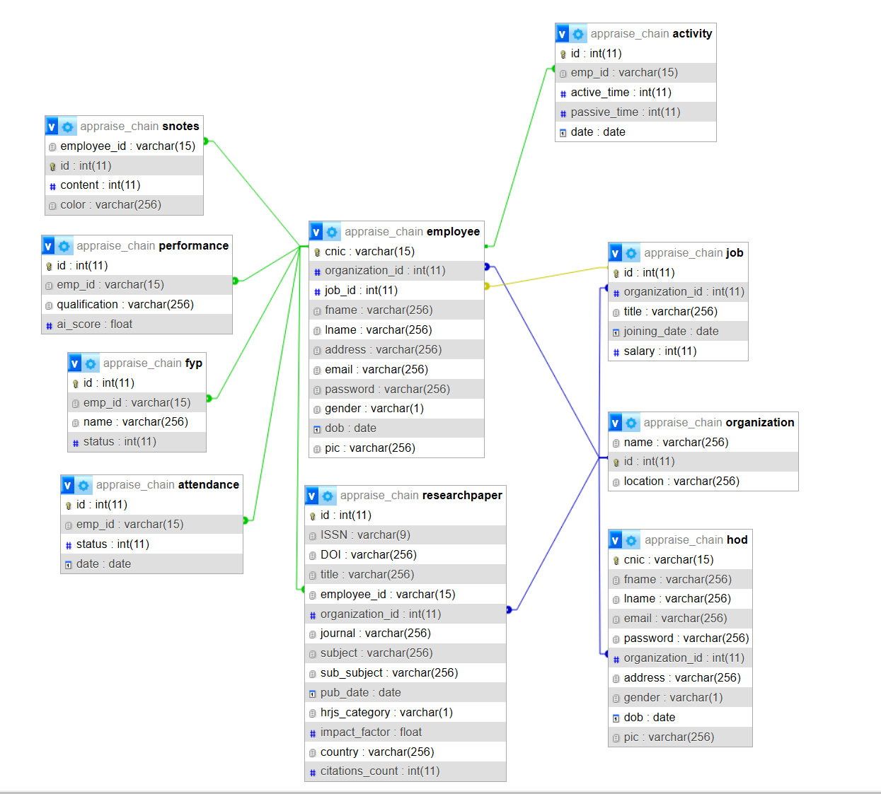
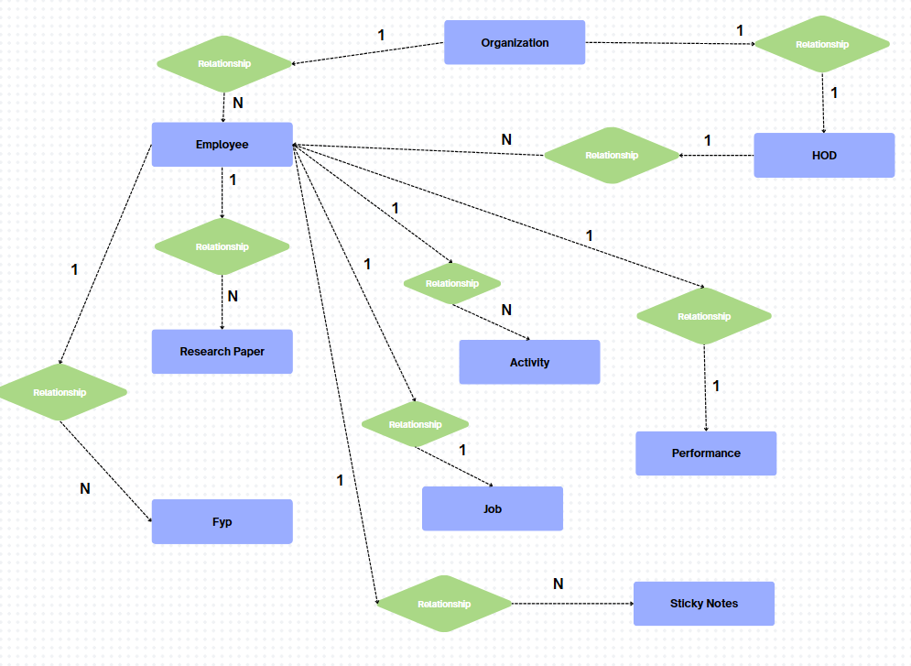

Data Dictionary

Data 1

Employee
Name |  | The researcher that will use our product
Alias |  | Researcher
Where-used/how-used |  | Researchers are registered through their respective head.  Researchers can login to their respective performance dashboard to view their progress such usage activity, research and much more. Will be able to insert research paper and get them verified automatically
Content description |  | Notation for representing content.
Column Name | Description |  | Type | Length | Null able | Default Value | Key Type
cnic | unique identifier |  | Varchar | 15 | NO | None | PK
organization_id | unique identifier of organization |  | Int | 11 | NO | None | Fk
job_id | unique identifier of a Job |  | Int | 11 | NO | None | FK
fname | First Name |  | Varchar | 256 | NO | None
lname | Last Name |  | Varchar | 256 | NO | None
address | address of employee |  | Varchar | 256 | YES | NULL
dob | date of birth |  | date | 8 | NO | None
email | unique email |  | Varchar | 256 | NO | None
password | password encrypted |  | Varchar | 256 | NO | None
gender | M/F |  | Varchar | 1 | NO | None
pic | file location of image |  | Varchar | 256 | YES | NULL

Data 2

HOD
Name |  | Head of the department, researcher/employee will work under him.
Alias |  | Hod
Where-used/how-used |  | Will register by them self through our signup form. will be able to see the researcher working/collaborating for him.  wil be able to use our AI model to evaluate employees research work
Content description |  | Notation for representing content.
Column Name | Description |  | Type | Length | Null able | Default Value | Key Type
cnic | unique identifier |  | Varchar | 15 | NO | None | PK
organization_id | unique identifier of organization |  | Int | 11 | NO | None | Fk
fname | First Name |  | Varchar | 256 | NO | None
lname | Last Name |  | Varchar | 256 | NO | None
address | address of employee |  | Varchar | 256 | YES | NULL
dob | date of birth |  | date | 8 | NO | None
email | unique email |  | Varchar | 256 | NO | None
password | password encrypted |  | Varchar | 256 | NO | None
gender | gender | M/F |  | Varchar | 1 | NO
pic | pic | file location of image |  | Varchar | 256 | YES

.
.

Data 3

Attendance
Name |  | Attendance of an employee
Alias |  | Attendance
Where-used/how-used |  | When the employee will login on their respective portal their attendance will automatically be saved in the database
Content description |  | Notation for representing content.
Column Name | Description |  | Type | Length | Null able | Default Value | Key Type
id | unique identifier |  | Int | 11 | NO | None | PK
emp_id | employee’s cnic |  | Varchar | 15 | NO | None | FK
status | absent or present |  | Varchar | 1 | YES | NULL
date | date |  | date | 8 | NO | None

Data 4

Activity
Name |  | Productive stats for an employee
Alias |  | Activity
Where-used/how-used |  | When an employee logs in their activity will be automatically tracked and the time spent working and time spent inactive will be stored in the database
Content description |  | Notation for representing content.
Column Name | Description |  | Type | Length | Null able | Default Value | Key Type
id | unique identifier |  | Int | 11 | NO | None | PK
emp_id | employee’s cnic |  | Varchar | 15 | NO | None | FK
active_time | time spent working |  | Varchar | 15 | NO | None
passive_time | time spent inactive |  | Varchar | 15 | NO | None
date | date |  | date | 8 | NO | None

Data 5

Performance
Name |  | Performance stats for the employee
Alias |  | AI models evaluation
Where-used/how-used |  | When the HOD will hit evaluate employee button, our AI model will evaluate employee upon their KPIs and will store the result of the model in the database
Content description |  | Notation for representing content.
Column Name | Description |  | Type | Length | Null able | Default Value | Key Type
id | unique identifier |  | Int | 11 | NO | None | PK
emp_id | employee’s cnic |  | Varchar | 15 | NO | None | FK
qualification | Qualification of employee |  | Varchar | 256 | NO | None
ai_score | output of our Appraisal AI model |  | Varchar | 256 | YES | NULL

Data 6

Research Paper
Name |  | Research Paper written by employee/researcher
Alias |  | Researcher Paper
Where-used/how-used |  | Employee/Researcher will insert their research work automatically get it verified and get tested that that research work is their own and not stolen
Content description |  | Notation for representing content.
Column Name | Description |  | Type | Length | Null able | Default Value | Key Type
id | unique identifier |  | Int | 11 | NO | None | PK
ISSN | ISSN number of research work |  | Varchar | 9 | NO | None
DOI | unique identifier of research |  | Varchar | 256 | NO | None
title | Name of the research paper |  | Varchar | 256 | NO | None
employee_id | employee’s cnic |  | Varchar | 15 | NO | None | FK
organization_id | unique identifier of organization |  | Int | 11 | NO | None | Fk
journal | Name of the publishing journal |  | Varchar | 256 | NO | None
subject | subject area of research |  | Varchar | 256 | NO | None
sub_subject | more detailed area of research |  | Varchar | 256 | NO | None
pub_date | date of publication |  | date | 8 | NO | None
hrjs_category | HRJS category imposed by HEC |  | Varchar | 1 | NO | None
impact_factor | Impact of the research |  | Float | 16 | NO | None
country | country origin |  | Varchar | 256 | NO | None
citations_count | number of citations |  | Int | 11 | NO | None

Data 7

Job
Name |  | Job title of the researcher
Alias |  | job
Where-used/how-used |  | Employee will have a job title
Content description |  | Notation for representing content.
Column Name | Description |  | Type | Length | Null able | Default Value | Key Type
emp_id | employee’s cnic |  | Varchar | 15 | NO | None | FK
Id | unique identifier for a job |  | Int | 11 | NO | None | PK
organization_id | unique identifier of organization |  | Int | 11 | NO | None | Fk
title | Job title |  | Varchar | 256 | NO | None
joining_date
salary

Data 8

FYP
Name |  | final Year Projects
Alias |  | Final Year Projects being supervised
Where-used/how-used |  | this is the amount of fyps that the employee is supervising and how many are completed and how many needs more attention
Content description |  | Notation for representing content.
Column Name | Description |  | Type | Length | Null able | Default Value | Key Type
id | unique identifier for a fyp |  | Int | 11 | NO | None | PK
emp_id | employee’s cnic |  | Varchar | 15 | NO | None | FK
name | Name of the project |  | Varchar | 256 | NO | None
status | Status of fyp |  | Int | 1 | YES | NULL
due_date | due date for the task |  | date | 8 | NO | None

Data 9

Organization
Name |  | Name of the organization that connects HOD and researcher
Alias |  | Org
Where-used/how-used |  | Parent node/root of HOD and Employee. Both are part of an organization
Content description |  | Notation for representing content.
Column Name | Description |  | Type | Length | Null able | Default Value | Key Type
name | Name of the organization |  | Varchar | 256 | NO | None
id | unique identifier for a fyp |  | Int | 11 | NO | None | PK
location | Location of the organization |  | Varchar | 256 | NO | None

Application Design
[A detailed application design should include the following:

- Detailed Sequence diagram with parameter list
- State Transition Diagram
- DFD level 1 diagram]

Sequence Diagram

<Sequence Diagram 1>
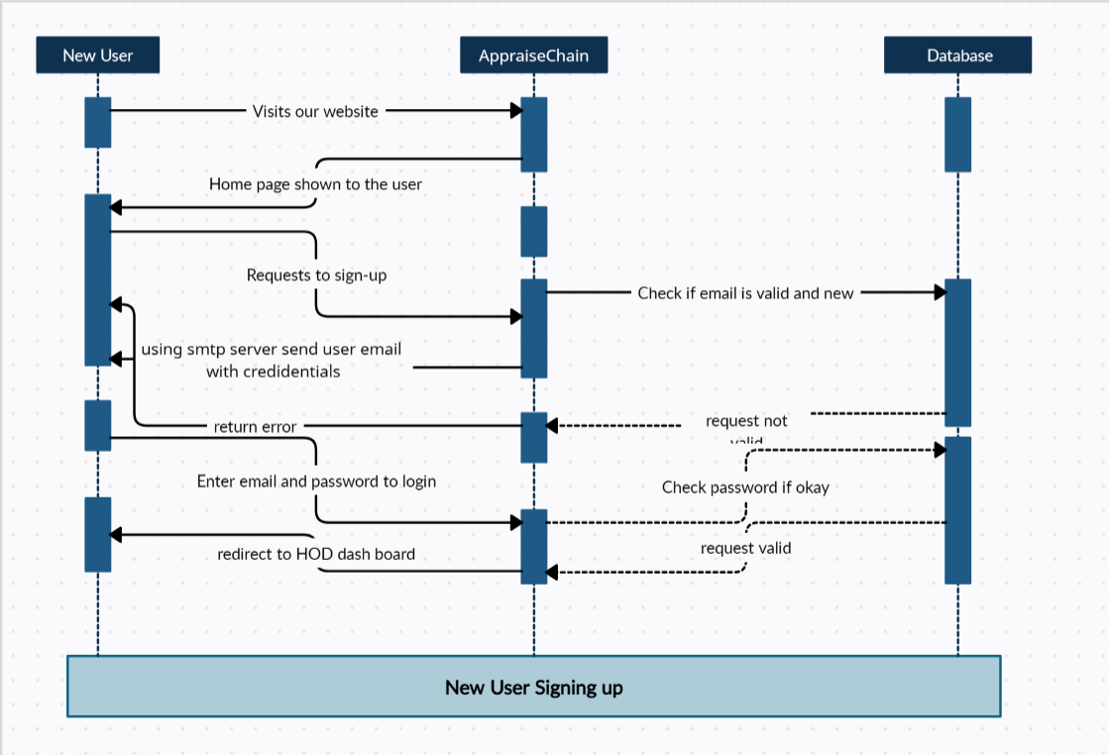
new users who come to our website will see our home page, users will be prompted to login or signup. Upon signup an email will be sent to the user with login credentials. if a user logs in with correct credentials he/she is directed to the HOD dashboard.

<Sequence Diagram 2>
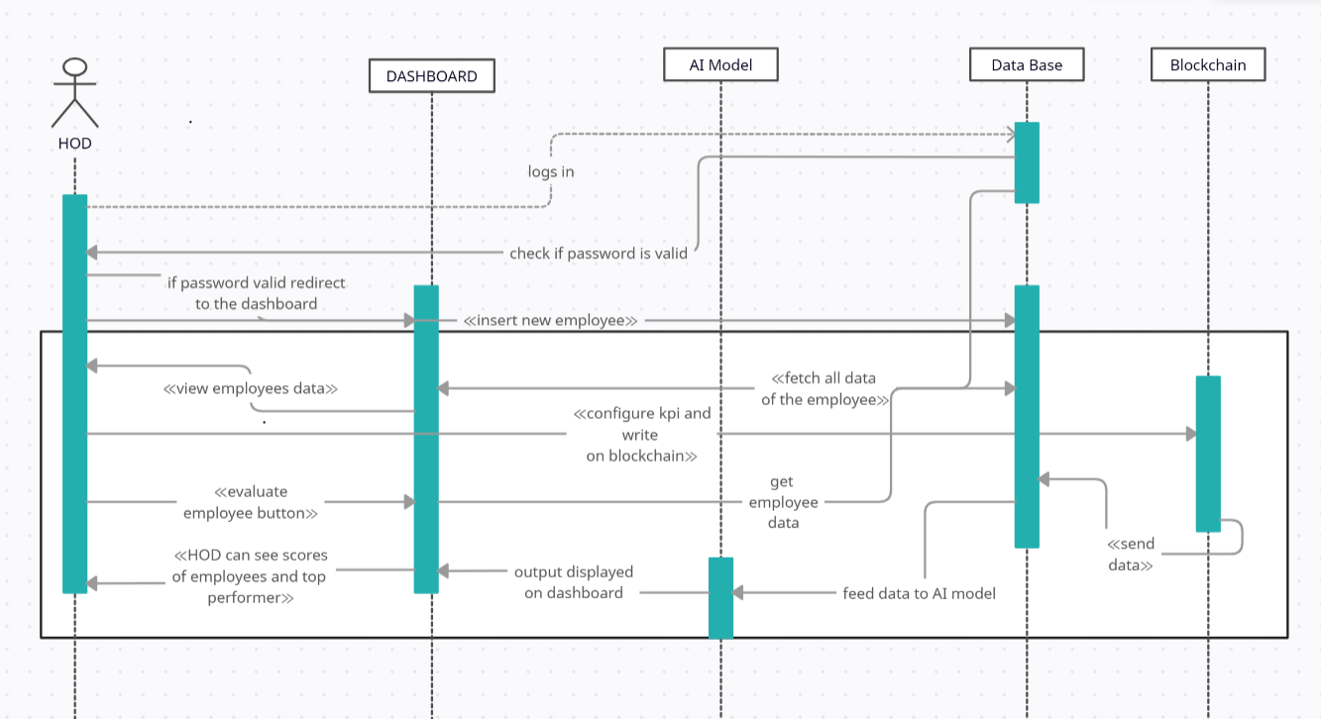
- HOD can log in to to view dashboard
- can see all info of the employees
- can insert new employees as well
- can update KPIs and write promotion criteria that will go on the blockchain
- this data will be read and used by out AI model along with the other data of the employee stored in the database
- the AI model will give result according to the data of the employees
- HOD will be able to see the evaluated score of the employees.

<Sequence Diagram 3>
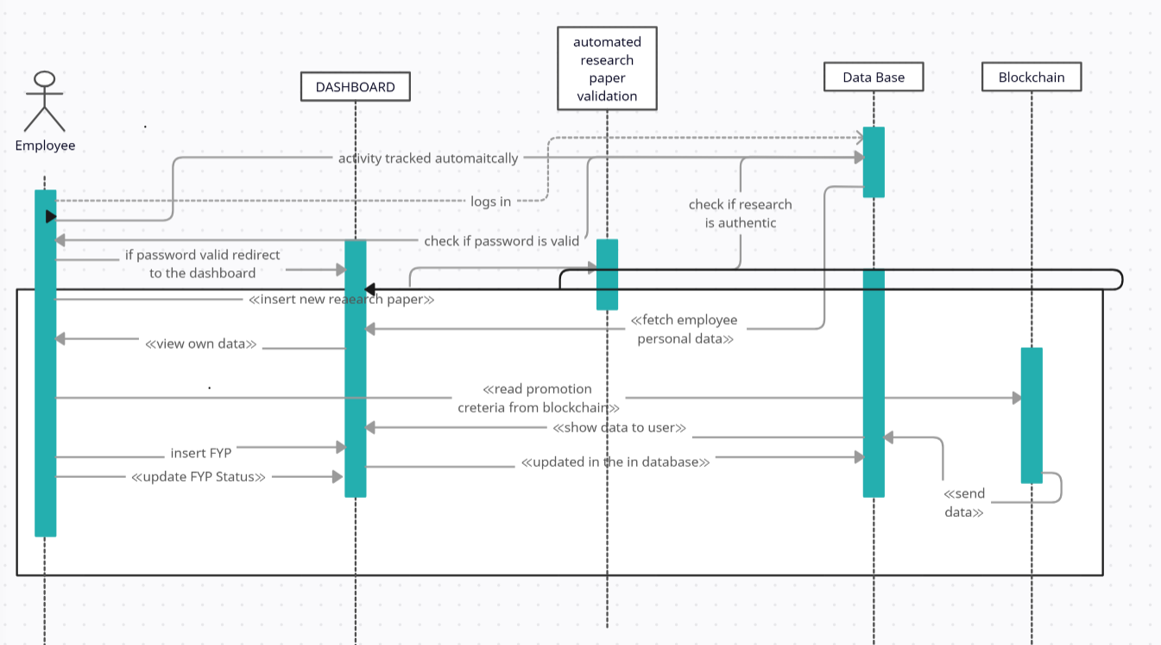
Employees logging into his dashboard can only view their own data, as soon as he logs in the tracker will track and track users activity if the user is idle or on a break notification will be sent. Employees will be able to read promotion criteria from the blockchain. And will work on KPIs accordingly. Employees will be able to insert FYPs and update their status, if the due date is past so status won't be updated and that FYP will remain pending. Employees can view his AI score. Employees can only read from blockchain.

State Diagram

<State Diagram 1>

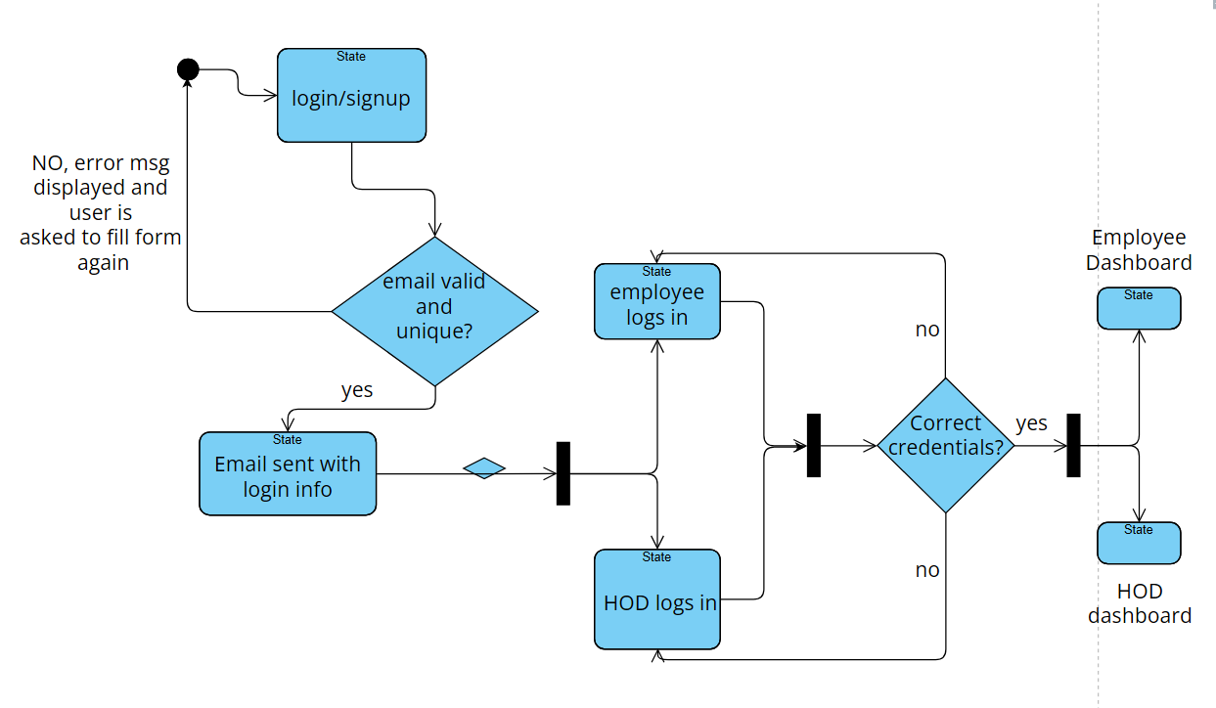
Over all login/signup process and how HOD and Employees are directed to their respective dashboards

<State Diagram 2>
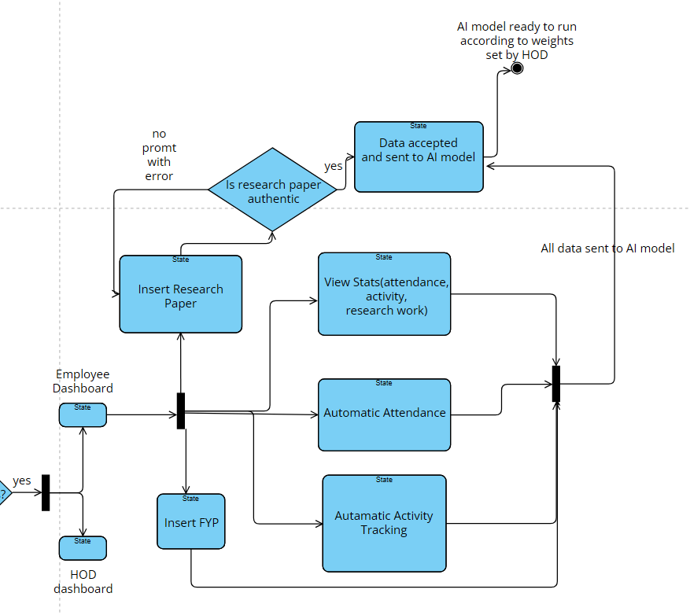
This shows the overall life cycle of an employee. Employee will log into his/her account and their attendance will be marked automatically and their activity will be tracked automatically, they can insert FYPs that they have to do before due date,they can insert research paper that they have written ONLY if they try to cheat they'll be prompted with an error, Research paper will be automatically checked to see if employee is an actual author if the research. Employees can view his stats on the dashboard in the form of charts and graphs. He/she can also view his AI score to see how he/she is performing on the set configured KPIs set by the HOD that will be available for all to see on the block chain.

<State Diagram 3>
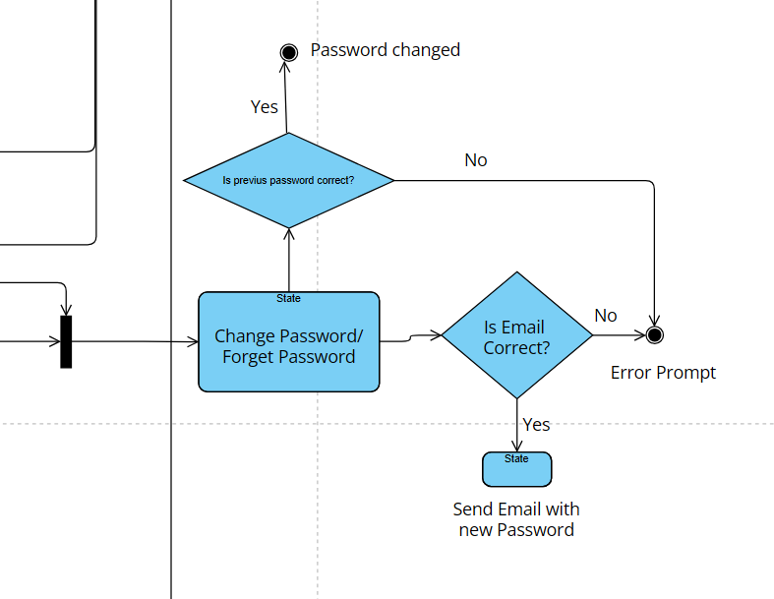
This shows the overall process if the employee or HOD forgets their password or wants to change their password so how they can do it using our system.

<State Diagram 4>
      - 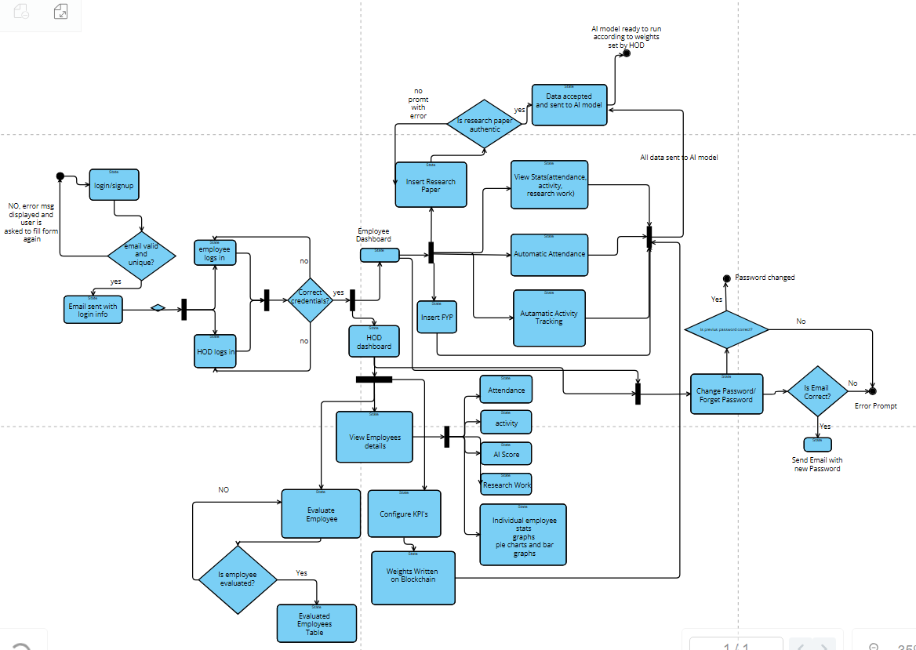
This is the overall state diagram of the whole system.

<State Diagram 5>

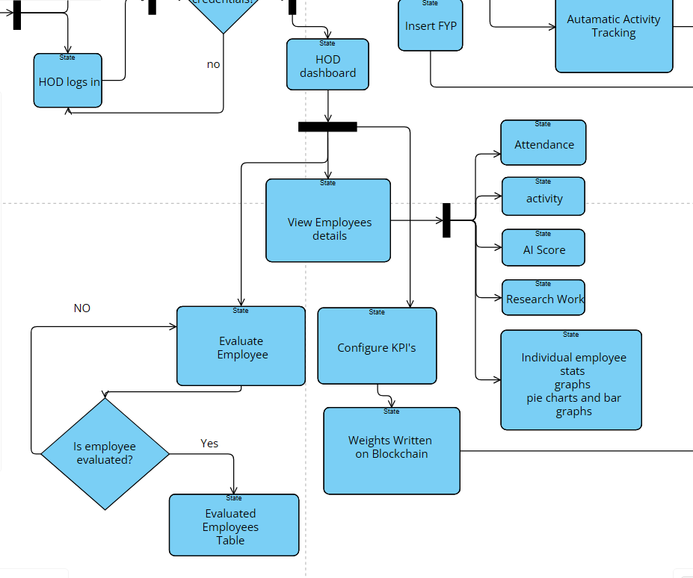
This is the overall experience that the HOD will have on our website. HOD will be able to view stats of all employees, he will be able to view individual stats as well, HOD will be able to configure weights for the AI model which will later be appended to the rule/appraisal contract on the blockchain. This then will be read by the AI model when evaluation for the employee will take place. HOD will be able to view the AI score of the employees, if the employee is not evaluated, so HOD will be able to evaluate the performance of the Employees through our AI model with the click of a button.

References
- Journal Article
M. R. Wicaksono, A. K. Sari, and A. F. Habiburrahman, “On the Design of a Blockchain-based Fraud-prevention Performance Appraisal System,” International Journal of Computer and Communication Systems, vol. 14, no. 1, pp. 1–9, 2020. [Online]. Available: https://doi.org/10.22146/ijccs.67669
- Conference/Journal Paper (PDF from IRJET)
S. S. Jadhav, A. P. Mahesh, and S. J. Patil, “Corruption-less Appraisal System using Blockchain,” International Research Journal of Engineering and Technology (IRJET), vol. 9, no. 6, pp. 1442–1445, June 2022. [Online]. Available: https://d1wqtxts1xzle7.cloudfront.net/91711775/IRJET_V9I6193-libre.pdf
- Government/Policy Document
Higher Education Commission (HEC), HEC Journals and Publication Policy 2024. HEC, Pakistan, 2024. [Online]. Available: https://www.hec.gov.pk/english/services/faculty/journals/Documents/HEC%20Journals%20and%20Publication%20Policy%202024.pdf
- Website
Higher Education Commission (HEC), “HEC Services and Resources.” [Online]. Available: https://www.hec.gov.pk
- Web-based Resource/Database
Higher Education Commission, “HEC Journal Recognition System (HJRS),” HEC Pakistan. [Online]. Available: https://hjrs.hec.gov.pk
- Book
Author(s), Title of the Book. Unpublished resource, Google Drive. [Online]. Available: https://drive.google.com/file/d/1N9Hd2NumMq8DrEhjA2XxnwyS9NXG1IYn/view
- Web-based Blockchain Development Resource
Multichain, “Blockchain Resources for Developers,” Multichain Developers. [Online]. Available: https://www.multichain.com/developers

Appendices
[Include supporting detail that would be too distracting to include in the main body of the document.]

